Utilisation Assessment
Prepared by <SONARSOURCER> for:

LOGO HERE

Executive Summary
Sonar and <CUSTOMER> collaborated to evaluate the current maturity of their SonarQube usage and to provide recommendations in order to improve and get more value from the tool. The main conclusions are the following:
- List main conclusions.
- Summarize suggested improvements
- If on old Sonar versions, advertise upgrade and new features
- Example:
- The current technical implementation of Sonar is good. <Customer> regularly upgrades SonarQube, allowing access to the latest and greatest features of the product.
- The right authentication and authorization scheme are in place.
- There are important improvements that could be made in terms of Code Quality and Security governance to enforce quality gates rather than making them only informational. A certain number of configuration adjustments are recommended so that this enforcement is not seen as a burden for the developers, in particular defining <Customer> specific quality gate consistent with <Customer> current development practices.
- There are more software development projects that should be onboarded on SonarQube, notably C/C++ code developed for embedded systems.
- SonarQube for IDE (ex-SonarLint) should be more utilized by developers to detect issues in the code early (shift left) and fix them even before committing the code.
- An increased usage of portfolios should allow for better management reporting of the overall <Customer> code quality and security.
- <Customer> may not be using a certain number of recently added SonarQube features (Secrets detection, AI capabilities, C/C++ seamless scanning and more). It would be worth reviewing these features and enabling those features if of interest.
- Some features coming in 2025.3 end of May could be of interest to <Customer> (SCA, MISRA C++, Rust language support)

The Sonar Maturity Model
In order to deliver software that is of high quality, reliable, maintainable, and secure, it is imperative that the underlying code is robust. By following best coding practices, organizations can achieve the agility, velocity, and scale of development needed for their business goals.

Sonar has defined a maturity model designed at:
- Assessing the current Sonar maturity of a given organization, and
- Providing recommendations on how to increase this maturity in order to maximize the value of the Sonar ecosystem.

This maturity model defines 5 levels of maturity. It is described in detail in the first annex of this document, for reference.
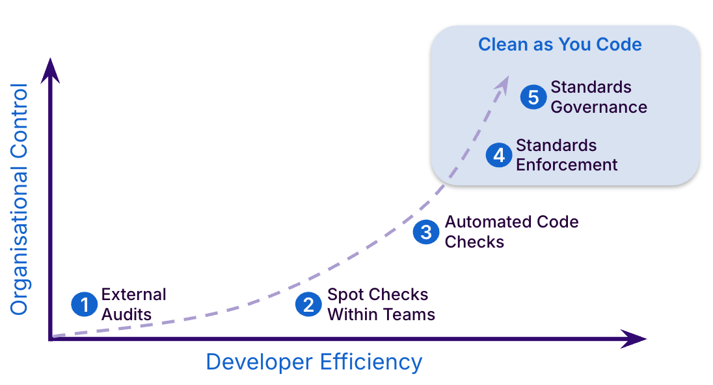

An important aspect of this maturity is the adoption of the Sonar recommended methodology to primarily focus on the new code.
This means setting strict quality and security requirements on the new code, to prevent leaking more issues in the code concerning quality and security requirements (perpetually accumulating technical debt in the code). The focus on new code can also be combined with minimum quality and security criteria on the overall code to also enforce that the legacy code does not contain any serious issues (higher severity bugs or vulnerabilities for instance). See the "dual strategy" appendix at the end of this document for details.

<Customer> Current Environment

Installation
- SonarQube Enterprise Edition 10.6
- Connected to GitHub, BitBucket
- No reported performance or technical issues

Utilization
- ~3.6M lines of code analyzed
  - License entitlement is 5M lines of code
- ~500 users
  - out of ~800 total developers
- ~885 Projects onboarded

Code Analysis
- Code analysis is automated as GitHub Actions and BitBucket Pipelines
- Code analysis is triggered on commit to GitHub and BitBucket
- Developers are aware of but are not using SonarQube for IDE in their IDEs (VSC, VS, IntelliJ, and Eclipse)

Governance
- Quality Gates are not used to fail pipelines or block merges
- Individual teams manage their own Quality Profiles and Gates
- Noted that standardized Quality Profiles and Gates are available and recommended to teams but most are using their own
- SonarQube reports are consumed by teams and by the Security team

Assessment

Current Maturity Level
Based on the current state of your Sonar deployment, your integration level is:
Level 2: Spot Checks Within Teams
Level 2:  Spot Checks Within Teams | Benefits of this level:  - Access to analysis results via Sonar dashboards  - Ability to generate external reporting  - Tracking of issue backlog  - Access to education on best coding practices

Level 3: Automated Code Checks
Level 3:  Automated Code Checks | Benefits of this level:  - Access to analysis results via Sonar dashboards  - Analysis results are available within 24 hours of code commits  - Assignment of issues to individual Sonar users  - Code quality historical trends  - Ability to fail pipelines based on Quality Gate result  - Access to Sonar analysis results embedded in pull/merge requests  - Automated analysis integrated with CI pipelines
Level 4: Standards Enforcement
Level 4:  Standards  Enforcement | Benefits of this level:  - Automated analysis integrated with CI pipelines  - Access to analysis results through dashboards and embedded in pull/merge requests  - Assignment of issues to individual Sonar users  - Code quality historical trends  - Visibility to code quality and security trends  - New technical debt is prevented through Quality Gate enforcement  - Best practices integrated with the development process

Level 5: Standards Governance
Level 5:  Standards  Governance | Benefits of this level:  - Automated analysis integrated with CI pipelines and enforced at a corporate level  - Technical debt is reduced to minimal levels and manageable across engineering teams  - Best practices implemented at scale  - Usage of portfolios with up-to-date metrics  - Leaders' decision making processes driven by Portfolio and historical data

Recommendations
The next step in your Sonar evolution would be Standards Enforcement. Here are recommendations for how to get there:

Integrate with DevOps Platform(s)
Sonar’s products offer additional benefits when integrated with the DevOps platforms you are using. Each repository can be easily onboarded, set up for scanning, and tightly integrated so that you can begin to practice Clean as You Code.
- Integrate with GitHub
By connecting your SonarQube instance with GitHub, you can quickly set up Projects and report the Quality Gate status to your Pull Requests. See GitHub integration documentation.
- Integrate with Azure DevOps
By adding the SonarQube extension to Azure DevOps, you can easily add scanning to Azure Pipelines through the SonarQube extension. See Azure DevOps integration documentation.

Automate Code Scanning
In order to follow the Clean As You Code methodology, users should expect to receive feedback within twenty-four hours of committing. This requires that Sonar analysis is run in a timely manner through automation. See the Configuring branch analysis documentation.
- Automate Azure Pipeline branch scanning
Under the Triggers tab of your pipeline, select Enable continuous integration and select all the branches for which you want SonarQube analysis to run automatically.

Publish Quality Gate results
Displaying the Quality Gate status in the build summary increases the visibility of your analysis results. You can enable this by adding the “Publish Quality Gate Result” task to your pipelines.

Rationalize Quality Gates for proper governance

The precise quality gate conditions shall always be adjusted to the specific context of the customer but the general principles remain the same:
- Define a base quality gate that's the minimum enforced for all projects, and that shall be defined as the default quality gate. This quality gate should:
  - Focus on new code - i.e. only define criteria on new code. This will make this quality gate reachable even for the projects with a lot of legacy technical debt
  - Only enforce a level of code coverage if all projects practice unit tests. Otherwise remove any criteria on coverage
- Define 2-4 additional quality gates that incrementally raise the bar in terms of criteria:
  - Tighter criteria on new code: Some coverage or higher coverage, hotspots review, lower duplication
  - Minimal criteria on overall code: No vulnerabilities (and/or bug) above a certain severity

In the case of <CUSTOMER> the following quality gates inconsistencies have been noticed:
- 0% coverage as a criteria. It's better to remove the criteria altogether rather than giving any illusion that there is an expectation on coverage. (Note this will raise a note in the UI that the gate is not Clean as You Code compliant but it does not matter, and this note will go away in future versions of SonarQube).
The same applies for a 0% security hotspots review percentage. The criteria should be removed in that case
- Looser criteria on security than on reliability or maintainability: Typically security is the first area that a customer wants to have under control, before reliability or maintainability. Some quality gate require a looser criteria (rating B) on security than on reliability or maintainability (rating A), which is probably not the desired objective.
- Too loose criteria on new code
The general approach recommended by Sonar (see the "Dual strategy appendix at the end of this document) is to set relatively strict criteria on new code (stop introducing more issues or more tech debt when you start using SonarQube). Enforcing these criteria should not be a problem because the new code is clean up progressively (so there is no huge backlog of problems to fix).
In some <CUSTOMER> gates some criteria on the new code are really too loose, which will let developers continue to introduce problems (ex: Maintainability rating D, Reliability rating D)
- Inconsistency criteria:
Unfortunately, SonarQube does not prevent users to use gate criterias on metrics that should not be used in gates. In the case of <CUSTOMER>, the following are used in some gates, where they should not:
  - Duplicated blocks: Generally speaking metrics that are absolute count of something should not be used, because they are all dependent on the project context (size, existing technical debt). These metrics should be replaced by related percentages/density metrics, like duplicated line % in this case.
  - Duplicated files: This is probably a criteria that's very specific to a given project. It's better to use a low enough duplicated line % to ensure low duplication across a large set of projects.

Sonar can assist <CUSTOMER> in the review of the quality gates if needed.

Often seen bad practices:

Use anything but 0 maximum number of issues (vulnerabilities, bugs, code smells, dependency risks).
If the threshold is anything else than 0, it is arbitrary, and highly depends on the project current context.
- The criteria (and the quality gate as a consequence) will not be applicable to multiple projects.
- When upgrading SonarQube and using more rules to analyze the code, the absolute number of issues may be changing significantly so the quality gate criteria will no longer be working well
- The total number of issues is always dependent on the number of LoC concerned by the threshold
Better practices to mitigate the above problems are:
- Use a threshold of 0, but only for critical issues (blocker issues, critical issues metrics), to not force resolution of too many issues (only the few most severe ones)
- Use the rating metrics that would require to only solve issues of a given type above a given severity/impact
  - Reliability rating:
    - D means requiring to fix blocker bugs
    - C means requiring to fix critical aka high severity bugs and above (blocker too)
    - B means requiring to fix major aka medium bugs and above
    - A means requiring to my minor aka low bugs and above
  - Security rating:
    - D means requiring to fix blocker vulnerabilities
    - C means requiring to fix critical aka high severity vulnerabilities and above (blocker too)
    - B means requiring to fix major aka medium (MQR terminology) vulnerabilities and above
    - A means requiring to my minor (std terminology)/low vulnerabilities and above
- For Code Smell, reason in terms of density of issues rather than absolute numbers: Either use the maintainability rating that is a density:
  - Rating A, B, C, D, E means (respectively) a maximum tech debt ratio (density of code smells) of 5% max, 10% max, 20% max, 50% max and unlimited.
A and B are typical good thresholds, C sometimes. D and E never
  - Directly use the tech debt ratio metric with a % limit when it fits for you, but typically in the 3-5% range on new code and never more than 20% on overall code (which is already a very high density)
The technical debt ratio precise density calculation is explained in this documentation section
- Define too strict metrics on overall code
Unlike for new code where it is legit and possible to enforce strict quality criteria, every project has to live with various legacies and may have an overall quality level that is very variable.
Because of this, criterias on overall code, if any defined in a quality gate, should be relatively relaxed and only require developers to fix a few critical problems from the legacy overall code. Avoid
  - Requiring to fix too low severity issues / code smells (limit the requirement to high severity vulnerabilities and bugs)
  - Requiring any bar on duplication and coverage. Depending on the project history the current level maybe already better than the bar and therefore impose no effort from the developer, or significantly worse than the bar and is impossible to reach to pass teh quality gate rapidly
- Use metrics on overall code that are % (coverage, duplication, technical debt ratio principally).
Unlike for the new code, where every project is "equal", on overall code each project has its own legacy and may start from a different state (different coverage, duplication, TD ratio) and therefore it's impossible to define a threshold that would be suitable for multiple projects, the base principle of a company wide governance
- Define a quality gate for a single project
This is usually wrong because it defines criteria that are usually specific to the particular context of that project, and not a meaningful list that would implement a company with governance
The below gate examples provide a general guideline that can be tuned to the specific context and quality governance of your company.

Quality Gate - Base - Step 1 - Minimal requirements for projects with the lowest maturity

- Reliability issues on new code no greater than 0 (ie no new bugs)
- Security issues on new code no greater than 0 (ie no new vulnerabilities)
- Maintainability rating on new code no worse than A (ie low density of new maintainability issues/code smells)
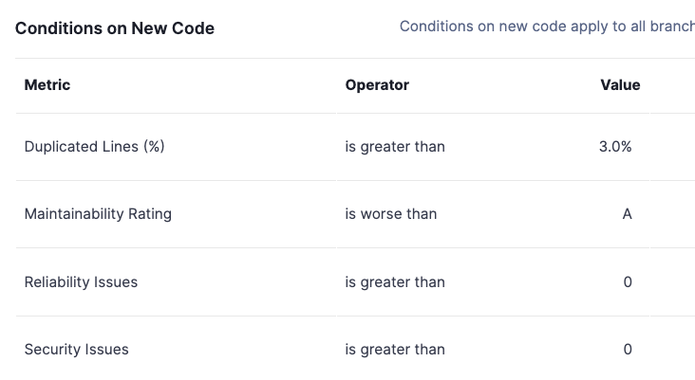
- Duplication on new code no higher than 3%

This gate focuses on new code only, makes sure that there are no new bugs or vulnerabilities added to the code, that there is a low number of maintainability issues added and that the code duplication of the new code is low.
All those criteria are relatively easy to achieve for any project, even with a substantial legacy technical debt.

This base quality gate should normally be defined as the default.

Quality Gate - Step 2

This quality gate can be used for projects that want to go beyond the minimal requirements of the base quality gate. It introduces criteria on coverage on new code (50% minimum), disallows any maintainability issues on new code and requires review of all new security hotspots.
It also introduces a minimum criteria on the overall code: All blocker and high severity vulnerabilities should be fixed.
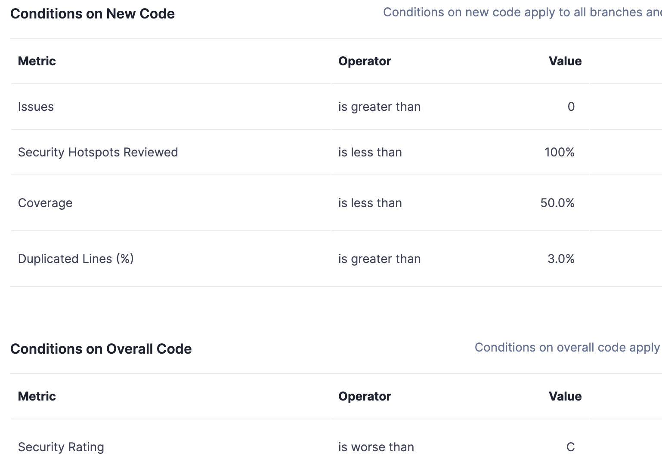

Quality Gate - Step 3

This is a quality that may be proposed for projects that really want or require excellent quality and security. On new code it requires a high level of coverage (80%) and a lower level of duplication than the base (2%).

It also introduces slightly stricter requirements on overall code: No blocker or
high severity vulnerabilities or bugs (security and reliability rating no worse than C), and no blocker maintainability issues.

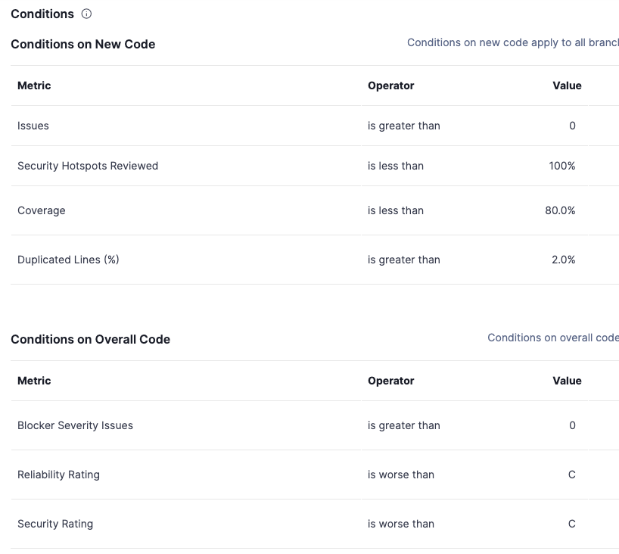

Possible variations

It is completely possible to make variations around the above suggested quality gates, as long as the progressivity of criteria is respected and the chosen criteria do make sense (they can be reached, they mean something in terms of quality).

For instance:
- Tune the % thresholds for coverage and duplication
- Provide a few more quality gate steps, e.g. define up to 5 incremental quality gates instead of the 3 given above
- Exclude hotspots review in case developers are not familiar with the hotspot review process yet
- Add criteria on dependencies licensing or vulnerability risks (in case the SonarQube Advanced Security add-on is available) Etc…

Validate New Code Settings
Defining what is considered new code is an important part of SonarQube's Clean as You Code approach to code quality and security. By focusing on code that's been added or changed since your new code definition, you can set consistent quality requirements and expectations. Your new code will be issue-free and you'll clean up the code you encounter along the way. See Defining New Code documentation.
- Set default New Code setting
The default New Code setting will be applied to all new Projects and is set through the global administration options. If your Projects consistently use Project versioning and update it upon release, the “Project Version” setting is the best default option. Otherwise, a “Number of Days” setting that closely matches your sprint/release cycle is a good default.
- Educate Project Administrators on New Code options
Project administrators should be aware of the additional options for New Code so that they can choose the option that best suits their teams' work. Options may be set at the Project level or on individual branches.

Enforce Quality Gates
- Add Branch Protection Rules to GitHub repositories
The best time to enforce coding standards is during a pull request review. Using GitHub Branch protection rules, you can block the merging of code when the Sonar Quality Gate fails. These rules should be set for all main branches on your repositories. See Github integration documentation
- Stop code promotion when Quality Gate is failing

To prevent the promotion of code with low quality, your organization should commit to stop promoting code when the Quality Gate is failing. This requires developers taking personal responsibility for their code by fixing issues as they are detected. Also, teams and leadership should be aware of and respect the Quality Gate status of their projects. Once this practice is in place, you can expect to stop the accumulation of technical debt and see a gradual increase in the quality of your overall codebase.

Stimulate the adoption of SonarQube for IDE Usage
SonarQube for IDE provides real-time feedback on code quality, helping developers identify and fix issues as they code, before the commit. It is available for free as part of your commercial license.
Developers should connect SonarQube for IDE to SonarQube Server for more advanced capabilities and a better developer experience:
- More languages and rules
  - Commercial languages
  - Advanced security and bug detection rules
- Issue synchronization
  - False positive suppression
  - Issue state change from the IDE
  - Review taint issues and hotspots directly in the IDE
- Focus on new code
- Request and apply AI Code Fix issues directly from the IDE
- Quality Profiles synchronization
- Quality Gates notifications

- Promote SonarQube for IDE adoption
Many users are not aware of the existence of SonarQube for IDE and the benefits of using Connected mode. Fostering awareness through communications and installation assistance can help increase adoption within your developer community. See SonarQube for IDE Connected Mode documentation.
Sonar can help in the promotion and awareness of SonarQube IDE with the developer community of the Customer.

Track SonarQube for IDE usage
It's possible to measure the progress of SonarQube IDE connected more adoption. The adoption is available SonarQube UI and via the Web API. Use this reporting to gauge the success of your promotion efforts.

The details of users, and in particular users using SonarQube IDE in connected mode is available through the API /api/v2/users-management/users. It returns, for each user, a JSON structure like the below

{
"id": "string",
"login": "string",
"name": "string",
"email": "string",
"active": "boolean",
"local": "boolean",
"managed": "boolean",
"externalLogin": "string",
"externalProvider": "string",
"externalId": "string",
"avatar": "string",
"sonarQubeLastConnectionDate": "string",
"sonarLintLastConnectionDate": "string",
"scmAccounts": ["string"]
}
The same information is also available in the SonarQube UI under Administration -> Security → Users menu.

Reporting Management
- Use Portfolio reporting as part of regular governance reviews
Use Portfolios to provide a consolidated view of releasability, security, reliability, maintainability, and security review across the relevant set of projects.
The Overview, Portfolio Breakdown, and Measures pages provide consolidated ratings, project breakdown, coverage visibility, duplication insights, and lines of code tracking. PDF reports and Portfolio security reports can also support periodic reporting for leadership, security, compliance, and audit stakeholders. See Managing portfolios documentation.

Annexes

The Sonar Maturity Model
The model helps guide organizations to achieve maximum value from Sonar's tools. This model is best used as a roadmap for adoption to ensure that your development community experiences the right level of efficiency while allowing the implementation of enterprise-wide coding standards. As an organization deepens its integration of Sonar, it will be well-positioned to execute the Clean as You Code methodology across software teams.

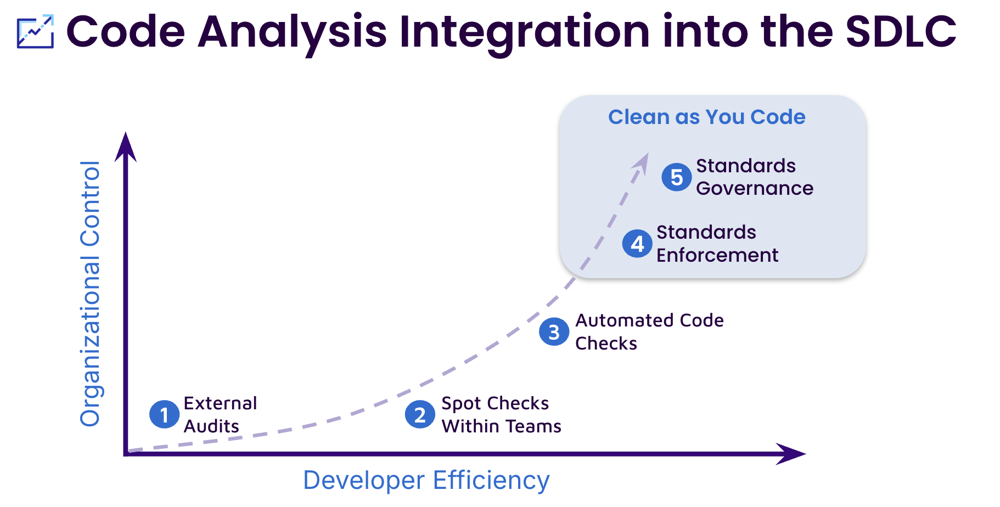
Level 1:  External Audits | Individuals outside of the development process are using SonarQube to do one-off audits. Results may be used to create a backlog of items to fix at a later date
Level 2:  Spot Checks Within Teams | Sonar tools are in use within individual teams. Developers begin to have the opportunity to act on issues and see the effects of their code changes.
Level 3:  Automated Code Checks | Analysis of code is automatically triggered via integration with a continuous integration (CI) process. Developers are positioned to fix issues as they are created.
Level 4:  Standards Enforcement | Quality standards are enforced within the development pipeline. Code is not allowed to be promoted if it does not meet standards. Organizations begin to decrease the accumulation of technical debt.
Level 5:  Standards Governance | Quality standards are enforced and governed centrally across the organization. Technical debt is reduced to manageable levels and Clean as You Code is fully implemented at scale. Leadership has access to up-to-date reporting and can make data-driven decisions to improve code quality.

Dual strategy on new code and on legacy code
The dual strategy recommended by SonarQube (and enabled by the new code concept in the product) is a software development practice that requires to:
- Enforce a high level of quality and security on new code. By always committing new code that complies to the requirements, you incrementally improve the quality of your code base.
Those issues are easy to fix as the context is fresh in memory and it's appealing to deliver the feature with no bugs.
- Enforce a minimal level of quality and security on the legacy code. Unlike for the new incremental code, where quality requirements should be high, and in order to not overwhelm developers with too many historical issues to fix, the requirement is to only fix the most critical problems (blocker or critical vulnerabilities and bugs).
More about the concept:
- Quality standards and new code

